1 | CreateaKanbanBoardtoVisualizetheTasks.  - CreateColumnsforToDo,In-ProgressandDone.  - Addat least5SampleTasks  - MovetheTasksacrosstheColumnstoSimulatethe Workflow. | JiraorTrello | CO1

Using Jira
Objective
To create a Kanban Board with To Do, In-Progress, and Done columns and simulate task movement.

Step 1: Login
- Go to jira.atlassian.com
- Login to Jira account.
Step 2: Create Project
- Click Create Project
- Select Kanban project
- Name: Kanban Workflow Project
- Click Create.
Step 3: Verify Columns
Ensure board has:
- To Do
- In Progress
- Done
(If not, configure columns in board settings.)
Step 4: Create Issues (Tasks)
Click Create Issue and add:
- Collect project requirements
- Design UI mockups
- Develop login module
- Test application
- Prepare final report
Step 5: Move Issues
Drag issues:
- First two → In Progress
- Then move one → Done
Step 6: Final Simulation
- Design UI mockups → Done
- Develop login module → In Progress

Using Trello

Step 1: Login
- Open browser → go to trello.com
- Login using Google / email account.
Step 2: Create a Board
- Click Create → Create Board
- Name it: Kanban Workflow Board
- Click Create.
Step 3: Create Columns (Lists)
Rename default lists as:
- To Do
- In-Progress
- Done
(Delete extra lists if any.)
Step 4: Add Sample Tasks
Under To Do, add these 5 cards:
- Collect project requirements
- Design UI mockups
- Develop login module
- Test application
- Prepare final report
Step 5: Move Tasks to In-Progress
Drag and drop:
- Collect project requirements
- Design UI mockups
➡ from To Do to In-Progress
Step 6: Move Completed Tasks to Done
After completion:
Drag Collect project requirements → to Done
Step 7: Continue Workflow Simulation
- Move Design UI mockups → Done
- Move Develop login module → In-Progress

Final Board Example
To Do | In-Progress | Done
Test application | Develop login module | Collect project requirements
Prepare final report |  | Design UI mockups

Result
Thus, a Kanban board was successfully created using Jira/Trello and tasks were moved across columns to simulate workflow.

2 | SketchaSimplePrototypeofaBusTicketBookingSystemusing Figma Tool | Figma | CO1

Objective
To design a simple interactive prototype of a Bus Ticket Booking System using Figma.

Step 1: Login to Figma
- Open browser → go to figma.com
- Click Login / Sign Up
- Login using Google or email.

Step 2: Create a New Design File
- Click New Design File
- Rename file as:
Bus Ticket Booking Prototype

Step 3: Create Frame (Mobile Screen)
- Click Frame Tool (F)
- Select device: Android / iPhone (375 × 812)
- This represents the mobile app screen.

Step 4: Design Home Screen
Add these UI elements:
Header
- Text: Bus Booking App
Input Fields
- From City
- To City
- Travel Date
Button
- Search Buses
Arrange neatly using rectangles and text.

Step 5: Design Bus List Screen
- Duplicate first frame (Ctrl + D)
- Add:
- Bus Name
- Time
- Price
- Book Now button
Create 2–3 sample bus listings.

Step 6: Design Seat Selection Screen
Duplicate frame again:
Add:
- Seat grid (rectangles as seats)
- Selected seat in different color
- Proceed to Payment button

Step 7: Design Payment Screen
Duplicate frame:
Add:
- Ticket summary
- Total price
- Payment method dropdown
- Pay Now button

Step 8: Create Confirmation Screen
Duplicate frame:
Add:
- ✔ Booking Confirmed
- Ticket number
- Travel details
- Download Ticket button

Step 9: Create Prototype Links
- Click Prototype tab
- Connect:
- Search Buses → Bus List Screen
- Book Now → Seat Selection
- Proceed → Payment
- Pay Now → Confirmation

Step 10: Preview Prototype
- Click Play ▶ icon
- Test full booking flow.

Step 11: Save and Share
- Click Share
- Set permission to Anyone with link – View
- Copy link.

Result
Thus, a simple prototype of a Bus Ticket Booking System was successfully designed using Figma.

3 | Thestakeholders haveconflictingviewsonthe user interface design foranE-Commercemobileapp.CreateaprototypeusingFigmatool  todiscusswiththestakeholderstogettheirfeedbackandapproval. | Figma | CO1
Objective
To design a clickable UI prototype of an E-Commerce mobile application using Figma in order to present multiple interface options and collect stakeholder feedback for approval.
Step 1: Login to Figma
- Open figma.com
- Login using Google or Email.

Step 2: Create New Design File
- Click New Design File
- Rename file as:
E-Commerce UI Prototype – Stakeholder Review

Step 3: Create Mobile Frame
- Select Frame Tool (F)
- Choose device: iPhone 14 / Android (375×812)
- This is the app screen.

Step 4: Create Home Screen – Version A
Design a clean minimal UI:
Elements:
- App logo + title
- Search bar
- Banner image
- Category icons
- Product cards
- Bottom navigation bar
Label frame as:
👉Home Screen – Version A (Minimal UI)

Step 5: Duplicate Frame for Version B
Duplicate frame (Ctrl + D)
Modify design to:
- Dark theme
- Larger banners
- Sidebar menu icon
- Bigger product cards
Label as:
👉Home Screen – Version B (Visual UI)
This helps compare conflicting stakeholder preferences.

Step 6: Create Product Detail Screen
Duplicate one frame:
Add:
- Product image
- Price
- Rating
- Description
- Add to Cart button
- Buy Now button

Step 7: Create Cart Screen
Duplicate frame:
Add:
- Product list
- Quantity buttons
- Total price
- Checkout button

Step 8: Create Payment Screen
Add:
- Address section
- Payment options
- Confirm Order button

Step 9: Create Order Confirmation Screen
Add:
- ✔ Order Successful
- Order ID
- Delivery date
- Continue Shopping button

Step 10: Create Prototype Navigation
Open Prototype Tab and connect:
From | To
Version A Home → Product | Product Detail
Version B Home → Product | Product Detail
Add to Cart | Cart Screen
Checkout | Payment Screen
Confirm Order | Confirmation Screen

Step 11: Preview Prototype
- Click Play ▶
- Test both Version A and Version B flows.

Step 12: Share for Stakeholder Feedback
- Click Share
- Set access to:
Anyone with link → Can comment
- Copy link and share with stakeholders.

Step 13: Collect Feedback
Stakeholders can:
- Add comments on screens
- Suggest UI changes
- Approve preferred version

Result
Thus, an interactive E-Commerce mobile app prototype was created using Figma to resolve stakeholder UI conflicts and obtain design approval.
4 | The string is a sequence of characters placed in double quotes (” “). Performing different operations on string data is called String Handling. Strings are immutable. Whenever a change to a String is made, an entirely new String is created. If we want to store a group of characters we can use a char array. String provides various methods to perform different operations on strings. Using Raptor draw a flowchart to display thetotal number of characters in the string and returns it. | Raptor | CO1

Objective
To design a RAPTOR flowchart that accepts a string, calculates the total number of characters in the string, and displays the result.(Deekshana, moshika)

Algorithm
- Start
- Read the string
- Find length of the string
- Display the length
- Stop

Step 1: Open RAPTOR
- Open RAPTOR application
- Click New Flowchart

Step 2: Insert Start Symbol
- RAPTOR automatically provides Start.

Step 3: Input the String
- Drag Input symbol
- Write:
Input str

Step 4: Process to Find Length
- Drag Assignment symbol
- Write:
count ← length(str)

Step 5: Display Result
- Drag Output symbol
- Write:
Output "Total characters = ", count
Start
Step 6: Stop
- RAPTOR automatically provides Stop.

Final Flowchart Structure
Input str

count ← length(str)

Output "Total characters = ", count

Stop

Step 7: Run the Program
- Click Run ▶
- Enter string:
Example: "Computer"
- Output will be:
Total characters = 8

Result
Thus, a RAPTOR flowchart was successfully designed to calculate and display the number of characters in a string.
5 | Using Raptor – Draw and validate a flowchart for a given string of lower case English alphabets. One can choose any two characters in the string and replace all the occurrences of the first character with the second character and replace all the occurrences of the second character with the first character. Using Raptor draw and validate the flowchart lexicographically smallest string that can be obtained by doing this operation at most once. | Raptor | CO1

Objective (Divyadarshini ,danustpriya)
To design and validate a RAPTOR flowchart that transforms a given lowercase string into the lexicographically smallest possible string by swapping two characters at most once.

Algorithm
- Read string str
- Find the first position i where a smaller character exists later
- Select two characters c1 and c2
- Replace all c1 with c2 and all c2 with c1
- Display the modified string

Step-by-Step RAPTOR Instructions

🔹 Step 1: Start RAPTOR
Open RAPTOR → Click New Flowchart

🔹 Step 2: Input String
Insert Input symbol
Input str

🔹 Step 3: Initialize Variables
Insert Assignment symbol
n ← length(str)
found ← false

🔹 Step 4: Outer Loop (i)
Insert Loop symbol (For loop)
fori ← 1 to n

🔹 Step 5: Inner Loop (j)
Inside loop:
for j ← i+1 to n

🔹 Step 6: Decision to Find Smaller Character
Insert Decision symbol
ifstr[j] <str[i] and found = false

🔹 Step 7: Store Swap Characters
Inside IF:
c1 ← str[i]
c2 ← str[j]
found ← true

🔹 Step 8: End Both Loops
Exit loops once found = true
🔹 Step 9: Replace Characters in String
Insert loop:
for k ← 1 to n
Inside loop:
ifstr[k] = c1
str[k] ← c2
else if str[k] = c2
str[k] ← c1
end if

🔹 Step 10: Output Result
Insert Output symbol
Output "Lexicographically smallest string = ", str

🔹 Step 11: Stop

Flowchart
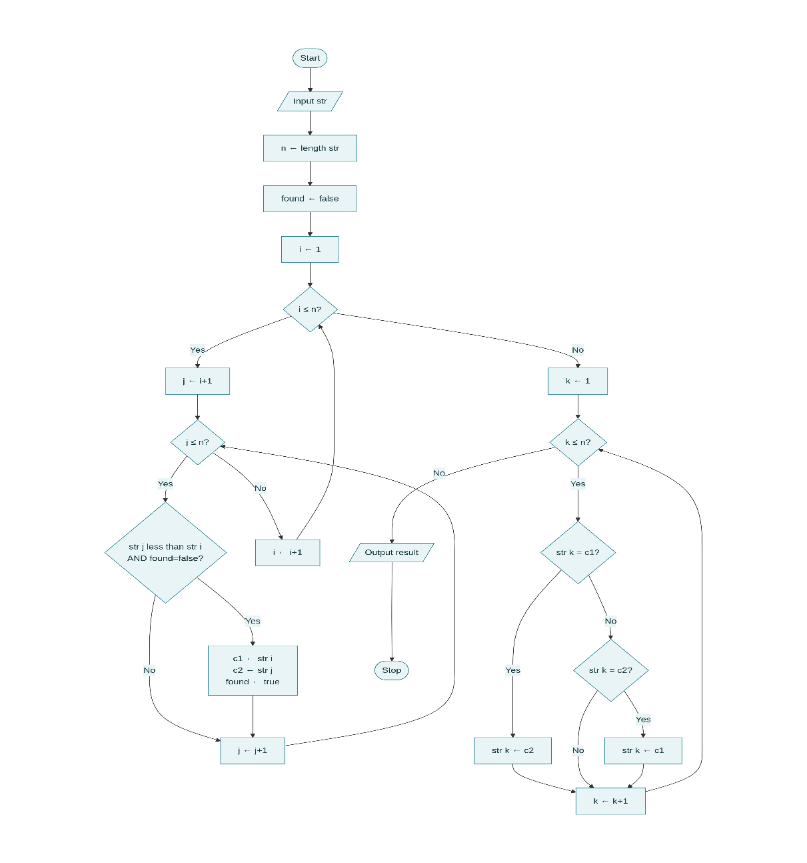
Result
Thus, a RAPTOR flowchart was successfully designed and validated to generate the lexicographically smallest string using at most one character swap.

6 | An online food delivery platform enables customers to browse restaurants, view menus, place food orders, make online payments, and track delivery status. Restaurants use the system to manage their menus and update order status, while delivery agents are responsible for accepting delivery requests and updating delivery progress. Design a Class Diagram, Use case Diagram and Activity Diagram for the Online Food Delivery System showing the relevant classes, their attributes, methods, and relationships. | Umbrello | CO1

Objective
To design UML diagrams (Class, Use Case, and Activity) for an Online Food Delivery System using Umbrello, representing system functionality, structure, and workflow.(mythresree,losane)

System Description (Short)
The Online Food Delivery System allows:
- Customers → browse restaurants, order food, make payments, track delivery
- Restaurants → manage menu and update order status
- Delivery Agents → accept orders and update delivery progress

🔹 PART 1: CLASS DIAGRAM

Step 1: Open Umbrello
- Open Umbrello UML Modeller
- Click File → New

Step 2: Select Class Diagram
- In left panel → Right click Logical View
- Select New Diagram → Class Diagram
- Rename as:
👉FoodDelivery_ClassDiagram

Step 3: Add Classes
Click Class icon and create:
- Customer
- Restaurant
- Menu
- FoodItem
- Order
- Payment
- DeliveryAgent

Step 4: Add Attributes & Methods
Customer
- customerId
- name
- address
- phone
Methods:
- browseRestaurants()
- placeOrder()
- makePayment()
- trackOrder()

Restaurant
- restaurantId
- name
- location
Methods:
- updateMenu()
- acceptOrder()

Menu
- menuId
Methods:
- showItems()

FoodItem
- itemId
- itemName
- price

Order
- orderId
- status
Methods:
- updateStatus()

Payment
- paymentId
- amount
- paymentStatus
Methods:
- processPayment()

DeliveryAgent
- agentId
- name
Methods:
- acceptDelivery()
- updateDeliveryStatus()

Step 5: Draw Relationships
Use Association / Aggregation lines:
- Customer → Order
- Restaurant → Menu
- Menu → FoodItem
- Order → Payment
- Order → DeliveryAgent

Step 6: Save Diagram
File → Save as FoodDelivery_ClassDiagram.uxf

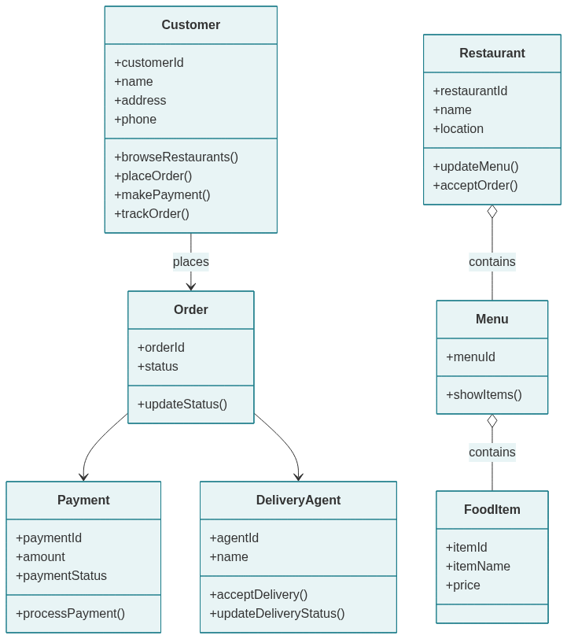

🔹 PART 2: USE CASE DIAGRAM

Step 1: Create Use Case Diagram
Right click Use Case View → New Diagram
Rename as: FoodDelivery_UseCaseDiagram

Step 2: Add Actors
Add:
- Customer
- Restaurant
- Delivery Agent

Step 3: Add Use Cases
Customer Use Cases
- Browse Restaurants
- View Menu
- Place Order
- Make Payment
- Track Delivery

Restaurant Use Cases
- Manage Menu
- Update Order Status

Delivery Agent Use Cases
- Accept Delivery
- Update Delivery Status

Step 4: Connect Actors to Use Cases
Use Association line:
- Customer → all customer use cases
- Restaurant → manage menu, update order
- Delivery Agent → delivery tasks

Step 5: Save Diagram
Save as: FoodDelivery_UseCaseDiagram.uxf

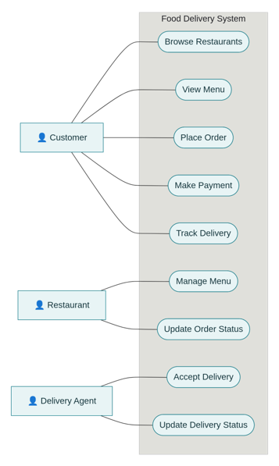

🔹 PART 3: ACTIVITY DIAGRAM

Step 1: Create Activity Diagram
Right click Logical View → New Diagram → Activity Diagram
Rename as: FoodDelivery_ActivityDiagram

Step 2: Add Activities in Sequence
- Start
- Browse Restaurants
- View Menu
- Select Food
- Place Order
- Make Payment
- Order Confirmed
- Restaurant Prepares Food
- Delivery Agent Picks Order
- Deliver Food
- Order Completed
- Stop

Step 3: Connect Flow
Use Control Flow arrows to connect each activity in order.

Step 4: Save Diagram
Save as: FoodDelivery_ActivityDiagram.uxf

Result
Thus, Class Diagram, Use Case Diagram, and Activity Diagram for the Online Food Delivery System were successfully designed using Umbrello UML Modeller.

7 | A college employs a large number of security personnel who are assigned duties at various locations across the campus. Each security person follows a duty schedule that includes date, duty start time, duty end time, and assigned location, ensuring that every campus location is covered. If a security person takes leave, it is recorded manually, and at the end of each month, salaries are calculated based on duties performed and leaves taken. Since manual handling of duty allocation, leave management, and salary calculation is time-consuming and complex, the college plans to develop an Online Security Management System to automate these activities. Develop Class Diagram, Use case Diagram and Activity Diagramto represent the workflow of the Online Security Management System. | Umbrello | CO1

Objective
To design UML diagrams for an Online Security Management System that automates duty allocation, leave management, and salary calculation of security personnel.

System Description (Short)
The system manages:
- Security personnel details
- Duty schedules
- Leave records
- Salary calculation
It automates manual processes for efficiency and accuracy.

🔹 PART 1 — CLASS DIAGRAM

Step 1: Open Umbrello
Open Umbrello UML Modeller
Click File → New

Step 2: Create Class Diagram
- Right-click Logical View
- Click New Diagram → Class Diagram
- Rename as:
SecurityManagement_ClassDiagram

Step 3: Create Classes
Add these classes:
- SecurityStaff
- DutySchedule
- Location
- Leave
- Salary
- Admin

Step 4: Add Attributes and Methods
🔹SecurityStaff
Attributes:
- staffId
- name
- phone
- designation
Methods:
- viewDuty()
- applyLeave()

🔹DutySchedule
Attributes:
- dutyId
- date
- startTime
- endTime
Methods:
- assignDuty()
- updateDuty()

🔹 Location
Attributes:
- locationId
- locationName
Methods:
- updateLocation()

🔹 Leave
Attributes:
- leaveId
- leaveDate
- reason
Methods:
- approveLeave()

🔹 Salary
Attributes:
- salaryId
- month
- amount
Methods:
- calculateSalary()

🔹 Admin
Attributes:
- adminId
- name
Methods:
- assignDuty()
- manageLeave()
- generateSalary()

Step 5: Draw Relationship
Use Association / Aggregation:
From | To | Relationship
SecurityStaff | DutySchedule | Association
DutySchedule | Location | Association
SecurityStaff | Leave | Association
SecurityStaff | Salary | Association
Admin | SecurityStaff | Association

Step 6: Save Diagram
File → Save

🔹 PART 2 — USE CASE DIAGRAM

Step 1: Create Use Case Diagram
Right-click Use Case View → New Diagram
Rename as:
SecurityManagement_UseCaseDiagram

Step 2: Add Actors
Add:
- Admin
- Security Staff

Step 3: Add Use Cases
Admin Use Cases
- Assign Duty
- Update Duty
- Approve Leave
- Calculate Salary
- Generate Salary Report

Security Staff Use Cases
- View Duty Schedule
- Apply Leave
- View Salary

Step 4: Connect Actors to Use Cases
Use association lines between:
- Admin → admin use cases
- Security Staff → staff use cases

Step 5: Save Diagram

🔹 PART 3 — ACTIVITY DIAGRAM

Step 1: Create Activity Diagram
Right-click Logical View → New Diagram → Activity Diagram
Rename as:
SecurityManagement_ActivityDiagram

Step 2: Add Activities in Order
- Start
- Admin Assigns Duty
- Security Staff Views Duty
- Security Staff Performs Duty
- Apply Leave (if required)
- Admin Approves Leave
- Monthly Duty Completion
- Calculate Salary
- Generate Salary
- Security Staff Views Salary
- Stop

Step 3: Add Decision Node
After Apply Leave
Decision:
Leave Approved?
- Yes → Continue
- No → Duty Continues

Step 4: Connect All Activities with Arrows
Use control flow arrows to show sequence.

Step 5: Save Diagram

Result
Thus, Class Diagram, Use Case Diagram, and Activity Diagram for the Online Security Management System were successfully designed using Umbrello UML Modeller.

8 | Cyclomatic Complexity in Software Testing is a testing metric used for measuring the complexity of a software program. It is a quantitative measure of independent paths in the source code of a software program. Cyclomatic complexity can be calculated by using control flow graphs or with respect to functions, modules, methods or classes within a software program. Cyclomatic complexity for a flow graph G is V(G)=E-N+2. Cyclomatic complexity is a software metric (measurement), used to indicate the complexity of a program, Cyclomatic complexity = E - N + P where, E = number of edges in the flow graph, N = number of nodes in the flow graph, P = number of nodes that have exit points. Find Cyclomatic Complexity for a graph having number of edges as 17, number of nodes as 13 and number of predicate nodes in the flow graph as 5. | Raptor | CO1

Given Data
Edges (E) = 17
Nodes (N) = 13
Predicate nodes (P) = 5

Formula used in Software Testing
Two common formulas:
- V(G) = E − N + 2
- V(G) = P + 1
We will compute using both to verify.

🔹 Manual Calculation

Method 1:
V(G) = E − N + 2
V(G) = 17 − 13 + 2
V(G) = 6

Method 2:
V(G) = P + 1
V(G) = 5 + 1
V(G) = 6
✅Cyclomatic Complexity = 6

Aim
To calculate Cyclomatic Complexity using RAPTOR.

Step 1: Open RAPTOR
Open RAPTOR Flowchart Tool.

Step 2: Insert Input Symbols
Add three Input symbols:
- Input E
- Input N
- Input P
Set prompts:
Enter number of edges:
Enter number of nodes:
Enter number of predicate nodes:

Step 3: Insert Assignment Symbol (Formula 1)
Add an Assignment symbol:
V1 = E - N + 2

Step 4: Insert Assignment Symbol (Formula 2)
Add another Assignment symbol:
V2 = P + 1

Step 5: Insert Output Symbols
Add Output symbols:
Cyclomatic Complexity using E-N+2 = V1
Cyclomatic Complexity using P+1 = V2

Step 6: Flowchart Order

Start
↓
Input E
↓
Input N
↓
Input P
↓
V1 = E - N + 2
↓
V2 = P + 1
↓
Output V1
↓
Output V2
↓
End

Step 7: Sample Input for Lab
E = 17
N = 13
P = 5

Output:
Cyclomatic Complexity using E-N+2 = 6
Cyclomatic Complexity using P+1 = 6

Result
The Cyclomatic Complexity of the given flow graph is:
👉V(G) = 6

9 | CreateaScrumProjectinJira.  - Addabacklogwithatleast5items(e.g.,"Createuser registration page", "Develop API for login").  - Prioritizethebacklogandcreatea1-weeksprint.  - Movebacklogitemsintothesprintandstartthesprint.  - Finally show the Screenshot of the sprint board at the start and end of the sprint. | Jira | CO2

Aim
To create a Scrum project in Jira, add backlog items, prioritize them, create a sprint, start the sprint, and track progress using the sprint board.

Requirements
- Jira account (Atlassian Cloud or Server)
- Browser access
Step 1: Create a Scrum Project
- Login to Jira.
- Click Projects → Create Project.
- Choose Scrum Software Development template.
- Click Use template.
- Select Team-managed project (recommended for lab).
- Enter:
  - Project Name: Library Scrum Project
  - Key: LSP
- Click Create Project.
Scrum project is created.

Step 2: Open Backlog
- From left menu → Click Backlog.
- You will see Product Backlog and Sprint area.

Step 3: Add Backlog Items (Minimum 5)
Click Create issue or + Create and add these as Story type:
Priority | Backlog Item
High | Create user registration page
High | Develop API for login
Medium | Design home page UI
Medium | Implement password reset
Low | Write unit test cases

Step 4: Prioritize the Backlog
- In Backlog view, drag issues up/down.
- Arrange in this order:
- Create user registration page
- Develop API for login
- Design home page UI
- Implement password reset
- Write unit test cases
Top = Highest priority.

Step 5: Create a 1-Week Sprint
- Click Create Sprint in Backlog.
- Rename sprint as:
- Sprint 1 – User Authentication Module
- Set duration to 1 week when starting sprint.

Step 6: Move Backlog Items to Sprint
Drag all 5 backlog items into Sprint 1 section.
Now Sprint contains all selected tasks.

Step 7: Start the Sprint
- Click Start Sprint.
- Set:
  - Sprint duration: 1 week
  - Start date: Today
- Click Start.
Sprint is now active.

Step 8: Sprint Board at Start (Screenshot 1)
- Click Active Sprint / Board.
- All tasks will be in To Do column.
📸Take Screenshot – Sprint Board at Start
(For lab submission: paste this screenshot)

Step 9: Move Issues During Sprint
Simulate work:
Issue | Move To
Create user registration page | Done
Develop API for login | In Progress
Design home page UI | Done
Implement password reset | In Progress
Write unit test cases | To Do
Drag cards between columns.

Step 10: Complete Sprint (End of Sprint)
- After moving tasks, click Complete Sprint.
- Jira will close sprint and show report.

Step 11: Sprint Board at End (Screenshot 2)
Open completed sprint report.
Take Screenshot – Sprint Board at End

Result
Thus, a Scrum project was successfully created in Jira with backlog prioritization, sprint planning, sprint execution, and sprint completion.

10 | UsethefollowingrequirementsforaLibraryManagementSystem:  - Addafeaturetosearchbooksbytitleandauthor.  - Implementanonlinebookreservationsystem.  - Generate monthly reports on borrowed books for administrators.  - Enableemailnotificationsforoverduebooks.  - AddsupportforQRcodescanningforborrowingandreturning books.  - Createauser-friendlydashboardforlibrarians.  - Allowuserstoreviewandratebooks.  - Integrateachatbotforuserassistance.  - Developamobileappversionofthesystem.  - Provide multi-language support.  Categorize each requirement using MOSCOW Method (Must-Have, Should-Have, Could-Have, or Won’t-Have) based on the following criteria:  - Impactontheusersandstakeholders.  - Feasibilityconsideringtime,budget,andresourceconstraints.  Finally Submit the completed Google Sheet or Excel file with all requirements categorized and justified. | Google Sheetor Excel | CO2

Objective
To categorize system requirements using the MoSCoW prioritization method based on user impact and feasibility, and document them in Google Sheets / Excel.

Step-by-Step Procedure (Google Sheets / Excel)

🔹 Step 1: Open Spreadsheet
Open:
- Google Sheets → Blank Sheet
OR
- Excel → New Workbook

🔹 Step 2: Create Column Headings
In Row 1, enter:
A1 | B1 | C1 | D1 | E1
Requirement ID | Requirement Description | MoSCoW Category | Justification | Priority Reason

🔹 Step 3: Enter Requirements
Enter all given requirements:
ID | Requirement
R1 | Search books by title and author
R2 | Online book reservation
R3 | Monthly borrowed books report
R4 | Email notifications for overdue books
R5 | QR code scanning
R6 | Librarian dashboard
R7 | Review and rate books
R8 | Chatbot integration
R9 | Mobile app version
R10 | Multi-language support

🔹 Step 4: Apply MoSCoW Categorization
Fill columns C, D, and E as follows:

Final Categorized Table
Req ID | Requirement | MoSCoW Category | Justification | Priority Reason
R1 | Search books by title and author | Must-Have | Core library functionality | Essential for users
R2 | Online book reservation | Must-Have | Improves accessibility | High user demand
R3 | Monthly reports | Should-Have | Important for administration | Operational efficiency
R4 | Email overdue notification | Must-Have | Prevents book loss | High impact
R5 | QR code scanning | Could-Have | Enhances speed | Requires extra hardware
R6 | Librarian dashboard | Must-Have | Required for management | Core system control
R7 | Review and rating | Could-Have | Improves engagement | Optional feature
R8 | Chatbot | Could-Have | Helps users | Resource intensive
R9 | Mobile app version | Should-Have | Improves accessibility | Medium feasibility
R10 | Multi-language support | Won’t-Have | High cost and complexity | Low priority initially

🔹 Step 5: Color Code (Optional but Recommended)
Apply colors:
- Must-Have → Green
- Should-Have → Blue
- Could-Have → Yellow
- Won’t-Have → Red
This improves visual clarity.

🔹 Step 6: Save File
Google Sheets:
File → Share → Copy link
Excel:
File → Save As → Library_MoSCoW.xlsx

📘 Explanation of MoSCoW Method
Category | Meaning
Must-Have | Critical for system
Should-Have | Important but not urgent
Could-Have | Optional features
Won’t-Have | Not in current version

Result
Thus, the Library Management System requirements were successfully categorized using the MoSCoW method and documented in Google Sheets / Excel.

